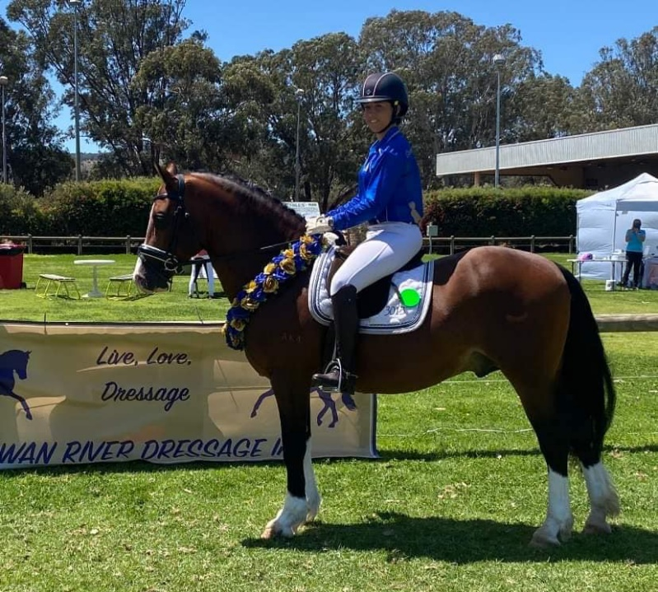

2023 SWAN RIVER DRESSAGE SERIES

Best Performed Welsh

Best Performed Part Welsh
Leaderboards

SERIES LEADERBOARD
The Swan River Dressage Club, supported by the Welsh Pony & Cob Society of WA. would like to recognize the highest performed Welsh Combination & Part Welsh combination across the 2023 Dressage Series.

Sponsored by
Welsh Pony & Cob Society Australia Inc. (WA)
Best Performed Welsh & Part Welsh – 2023 Series Leaderboard

We would like to thank the Welsh Pony & Cob Society Inc. (WP&CS) RPGWA for their generous donation of a presentation boxed rosettes to the winners of the 2023 Swan River Dressage Series Welsh Leaderboards for – Best Performed Welsh & Best Performed Part Welsh!

Conditions of Entry
- The horse must be registered with the WP&CS and the owner must be a current Financial Member with the WP&CS to nominate to be eligible for a leaderboard and must continue to be a financial member until series completion at the Spring Gala. You are NOT required to be a Swan River Dressage Member.
- To be eligible for the leaderboard you must attend and receive a score at 2 of the 3 events run over the series with the August event series final being compulsory to attend.
- Only the highest score from each attended event will be recorded. In cases where an eligible horse attends all events only the highest two scores will be used for the leaderboard.
- Competitor, Participant and Members tests are all eligible to gain scores towards the leaderboard
- The horse who received the highest aggregate score will be declared the winner of each leaderboard with the leaderboard winners presented at the August final.

Entering the Leaderboard
Entry into the leaderboard is free, to nominate for the leaderboard please email the horses WP&CS Registration number and owners Membership number to swanriverdressageevents@gmail.com Please title the email – WP&CS Leaderboard and also answer the Breed question on your nominate entry.

2023 Events
15th & 16th April – Series 1st
14th May – Series 2nd
Event 26th-27th August – Series 3rd

