Swan River Dressage Spring Festival
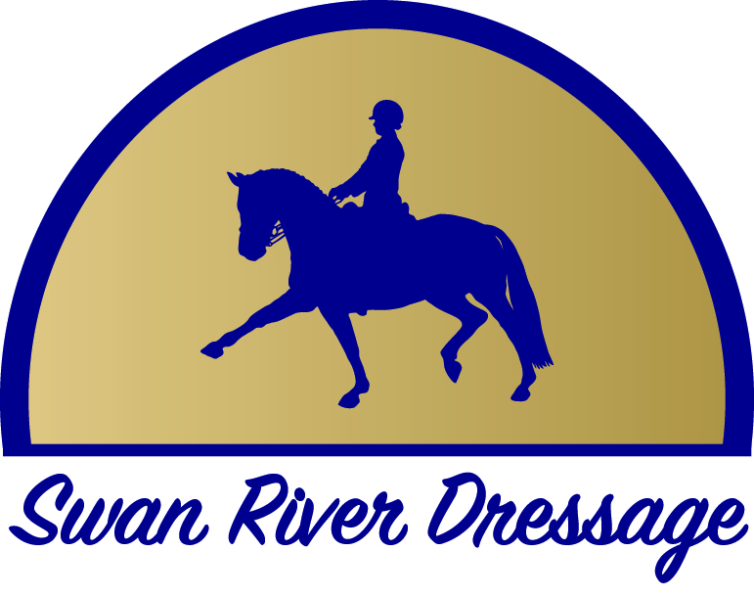
Championship Titles 2017
Swan River Dressage would like to congratulate the following
Championship winners from their Spring Dressage Festival

Participant Preliminary Champion
Roxleigh Ferdinand ridden by Wayne Brush
Participant Pony Preliminary Champion
Everton Nougat Gold ridden by Dinah Fleming
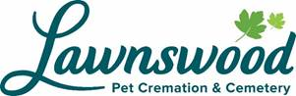
Competitor Preliminary Champion
Hirtensonne ridden by Natasha Allen
Competitor Pony Preliminary Champion
Kingstown Gwyneth ridden by Lauren King

Participant Novice Champion
Lebonstern Allure ridden by Rebecca Terriaca
Competitor Novice Champion

Ellis Brook Da Vinci ridden by Teagan Sutton, owned by Wendy & John Barker
Competitor Pony Novice Champion
Rowen Bluebell ridden by Tracy Dow
Swan River Dressage Elementary Champion
Belle Couture ridden by Bethwyn Kealley
Competitor Elementary Champion
Ellis Brook Da Vinci ridden by Teagan Sutton, owned by Wendy & John Barker
Competitor Pony Elementary Champion
Primrose Park Red Fox ridden by Kerry Dyjak
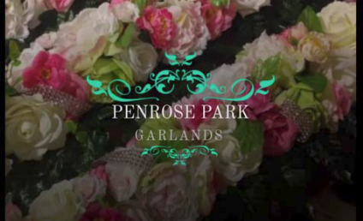
Competitor Medium Champion
Samford ridden by Ron Fleming
Competitor Advanced Champion
Samford ridden by Ron Fleming
Small Tour Champion (PSG + Intermediate I)
Bello Gallico ridden by Judy Weber
Runner Up A’Seduction ridden by Chloe Moon, owned by Alison Davis

Big Tour Champion (Intermediate II + GP)
Ellis Brook Hermes ridden by Wendy Barker
Runner Up Foxwood Whirlwind ridden by Suzanne Simons

